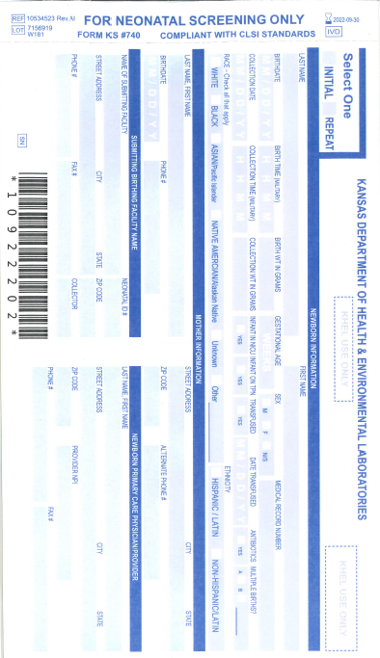

Write the Newborn’s Birth and Collection Weight in Grams

Write the Primary Care Physician’s/Provider’s Name, Address, NPI, Phone #, and Fax #

Check any Medical Interventions used for the Newborn

Check the Race and Ethnicity of the Newborn

Write the Neonatal ID of the Birthing/Submitting Facility

Write the Birthing/Submitting Facility’s Name, Address, Phone #, and Fax #

If the Newborn was a multiple Birth Check A for first, B for Second or Enter Birth order in the Space Provided

Write the Newborn’s Medical Record Number

Write the Time the Specimen was Collected

Write the Name or Initials of the Collector

Write the Mother’s Name, Address, Birthdate, Phone # and Alternate Phone #

Check the Sex of the Newborn

Write the Newborn’s Gestational Age

Write the Newborn’s First Name

Write the Newborn’s Time of Birth

Write the Date the Specimen was Collected

Write the Newborn’s Date of Birth

Write the Newborn’s Last Name

Check one box to indicate if this is an initial or repeat specimen